Assignment 4

Code:

%{  
#include <stdio.h>  
%}  
  
lower   [a-z]  
upper   [A-Z]  
  
%%  
{lower}  { printf("%c", yytext[0] - 32); };  
{upper}  { printf("%c", yytext[0] + 32); };    
. { printf("%c", yytext[0]); }  
%%  
  
int yywrap() {  
    return 1;  
}  
  
int main() {  
    yylex();  
    return 0;  
}

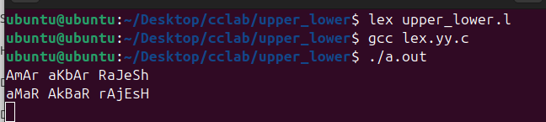

Code 2: File version

%{  
#include <stdio.h>  
%}  
  
lower   [a-z]  
upper   [A-Z]  
  
%%  
{lower}  { fprintf(yyout, "%c", yytext[0] - 32); }  
{upper}  { fprintf(yyout, "%c", yytext[0] + 32); }  
.        { fprintf(yyout, "%c", yytext[0]); }  
%%  
  
int yywrap() {  
    return 1;  
}  
  
int main(int argc, char *argv[]) {  
    if (argc != 3) {  
        fprintf(stderr, "Insufficient arguments! Usage: %s <input_file> <output_file>\n", argv[0]);  
        return 1;  
    }  
  
    yyin = fopen(argv[1], "r");  
    if (!yyin) {  
        fprintf(stderr, "Unable to open input file: %s\n", argv[1]);  
        return 1;  
    }  
  
    yyout = fopen(argv[2], "w");  
    if (!yyout) {  
        fprintf(stderr, "Unable to open output file: %s\n", argv[2]);  
        return 1;  
    }  
  
    yylex();  
  
    fclose(yyin);  
    fclose(yyout);  
  
    return 0;  
}

Output

